Final Project

Auto Factory DEVS simulation animated in Blender

Final Report Part II

Kin Wing Tsui (#100333520)

SYSC 5104 - Methodologies for Discrete-Event Modelling and Simulation

Fall 2007

Table of Contents

1. Introduction 1
2. Background 1
3. Execution Method 2
3.1 Execution Steps 2
3.2 Execution Options 4
4. Simulation Elements 4
5. Simulation Execution Results 5
5.1 Animation Timing 5
5.2 Object Deceleration 6
5.3 Animation Frames and Continuous Loop 6
6. Conclusion 7

1. Introduction

The purpose of this project is to animate a DEVS simulation of an auto factory in Blender using CD++ MA and LOG files. Blender is an open-source graphics rendering engine and 3D animation software that has a number of features that can assist in visualizing DEVS and Cell-DEVS simulation models. A script was written to demonstrate that a DEVS model can be animated in Blender using CD++ files.

A number of tools are currently in use for visualizing DEVS and Cell-DEVS models, such as DEVSView and CD++ Modeler, using a variety of visualization software, such as OpenGL and VRML. However, producing high quality 3D models in these visualization tools are often challenging and time consuming. This project attempts to demonstrate that Blender, the open-source 3D animation software, can produce custom-made high quality 3D animations of DEVS simulation effectively, using some hand-made models and Python scripts.

2. Background

Blender was chosen as the animation software for visualizing DEVS model for three main reasons: low cost, richness of features for animations, and capability of reading Python scripts.

Since Blender is open-source, the software is free of charge.

The software came from many years of development, and has features comparable to high-end commercial software such as 3DS Max and Maya. One feature that is particularly helpful for DEVS animations is the IPO curves. IPO curves are graphs that represent the change in value over time of a particular parameter, such as position, colour, or size of an object. By specifying a few key points along the time line at which the IPO curve must pass, Blender interpolates to define the full curve over time. Each key point is a Bezier point, such that its slope on either side of the point can be precisely defined in magnitude and direction. In that way, the interpolated animation can be as smooth or as jumpy as desired. Using IPO curves, an animation can be defined using just a few key frames.

Of the most interest to this project is the ability of Blender to interpret Python scripts. Python is a high-level programming language focused on code readability. Blender comes with an application programming interface (API) that Python scripts can use to modify objects and animations in Blender. This project heavily relies on the Python script to move objects in time, to modify IPO curves, and to load and execute CD++ files.

The model that is being simulated is the “Auto Factory Model” by Wanjun Sun. The model was chosen because it has models that can be unambiguously represented in a 3D visualization and shows the effectiveness of using the IPO curves and other features in Blender. Figure 1 shows the Auto Factory DEVS model.

The model runs as follows. The input of the model is the requested number of cars to be built. This value is passed on to each of the subfactory that builds the parts. After a manufacturing time, they are sent to a final assembly subfactory, as a value of 1 in the simulation. The engine parts are built differently; when the engine subfactory coupled model receives the requests, the piston and engine block are built separately. After the manufacturing time, the engine is assembled inside the engine subfactory. Only after this assembly, which consumes additional time, is the engine sent to the final assembly. After a while, the final assembly outputs a car, which is passed on as the output to the Auto Factory coupled model.

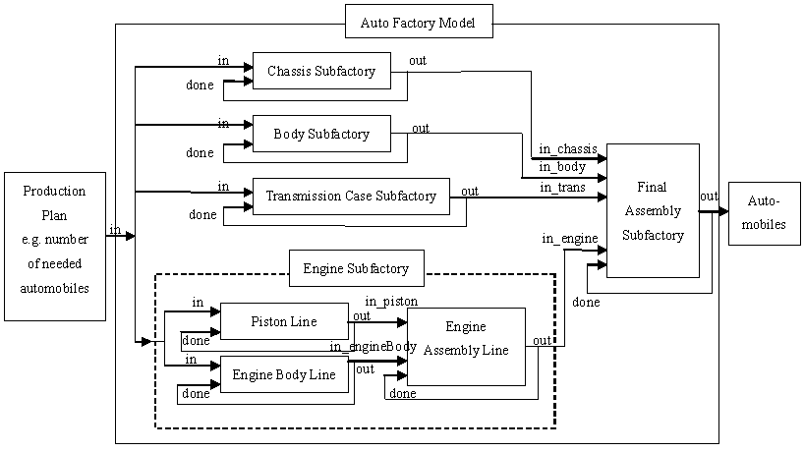
Figure 1 Auto Factory Model diagram

3. Execution Method

This project involves creating a Blender animation of an existing CD++ simulation model entitled “Auto Factory Model.” The associated CD++ MA and LOG files have already been produced and are used to drive the animation.

3.1 Execution Steps

To execute the animation:

- Copy the files named .B.blend, CM-AutoFact.ma and CM-AutoFact.log to the ".blender" subfolder under the Blender main directory (usually at
C:\Program Files\Blender Foundation\Blender\.blender\)
- Copy the file named devs-auto-gui.py in the “.blender\script” subfolder under the Blender main directory
- Run blender.exe (in the main Blender directory)
- Near the bottom right of the window, click on the slide-up menu button labeled Scripts (See figure 2)
- Choose Misc > CD++ Simulations; a black window should be loaded on the right hand side (See figure 3)
- Click on browse and select the CM-AutoFact.ma and the CM-AutoFact.log files
- Press Load to load the files into memory
- Press Execute to run the animation

To stop the animation, press ESC or right click on the animation.

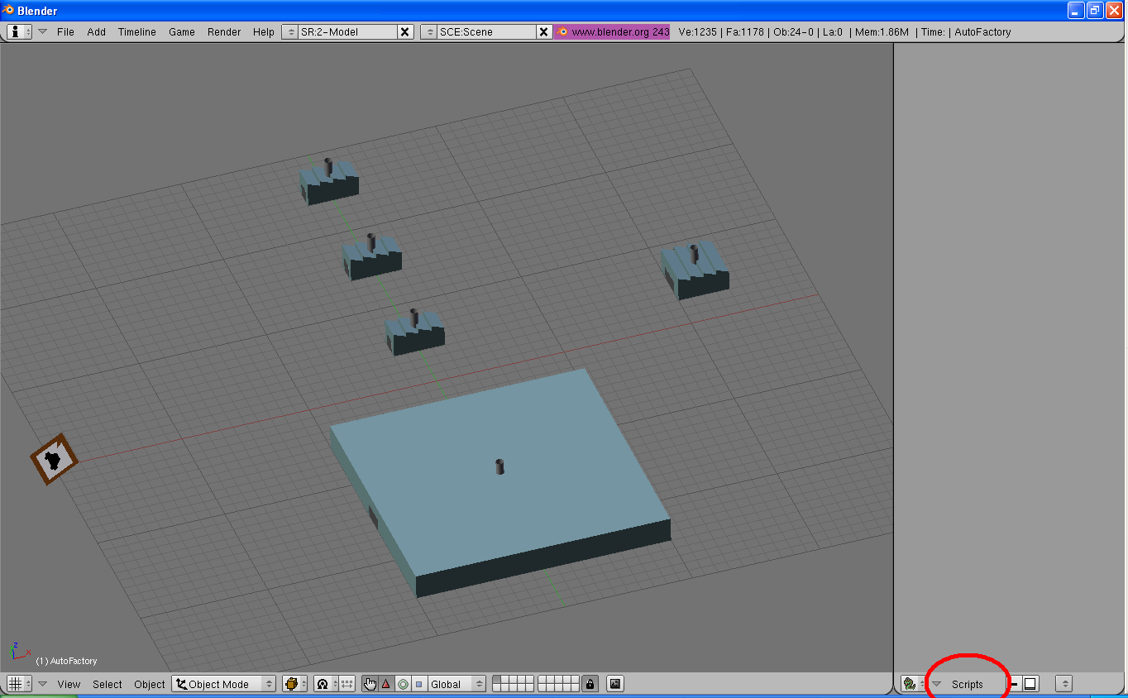
Figure 2 Location of the Scripts button

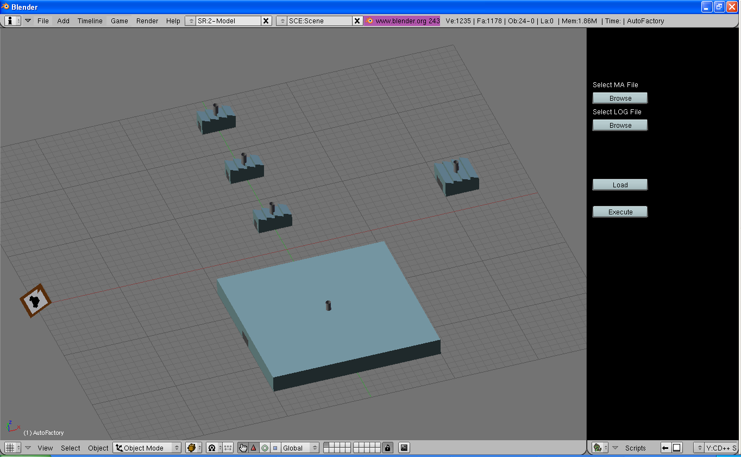
Figure 3 View of the CD++ Simulation bar on the right

3.2 Execution Options

To view the animation from a different angle, press the middle button over the animation and drag to rotate the model.

The Auto Factory coupled model contains four atomic models and one coupled model. The coupled model is represented by the large building near the bottom of the 3D model. To view inside this model, press 2. The animation must be stopped for this action to work. Press 1 to return to the top view of the model.

4. Simulation Elements

Each object in the 3D model represents an element in the Auto Factory model. They are listed in Table 1. It should be noted that these models are sculpted by hand after about two days of training through online tutorials. Depending on the quality desired, these models can be quickly produced using the available features of the 3D modeling tools in Blender.

Table 1 Auto Factory Model Elements
 | One or more Car Build Request(s)
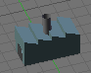 | Subfactory
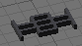 | Chassis
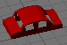 | Car Body
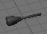 | Transmission
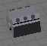 | Assembled Engine
 | Engine Assembly Line
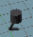 | Piston
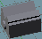 | Engine Body

5. Simulation Execution Results

Executing the animation produced several interesting observations:

- The animation appear to have gaps in time where no event is happening
- The final car leaves when parts are coming together
- All objects decelerates to a halt
- The animation loops back to the beginning when reaching the last frame

Each of these points will be discussed in this section.

5.1 Animation Timing

At first glance, the animation appears jumpy and can be slightly disorienting. The jerkiness does not, in fact, originate from the animation, but from the CD++ simulation itself. The author of the model has decided to input car build requests at times that are multiples of 2 seconds. Meanwhile, the manufacturing time and assembly time for all car parts are also exactly 2 seconds. The combined effect is that events in this simulation only happen every 2 seconds, and many events happen simultaneously.

This visually strange effect is also the reason why the final car appears to leave at the same time as when the parts come together. The parts that are coming together are actually those for the next car.

One particularity about this animation is that only one instance of each part is drawn (except for the car build requests). So then, for example, if a chassis is still in transition while another is coming in, the chassis model must jump back to the beginning of its route and travel its full path again. To prevent this sudden jumping motion, the animation time to travel the full path of the model is set at one second, such that the smallest simulation time unit allowed without the sudden jump is one second.

An effect of the one-instance limitation is that the object must return to its original location without appearing to return to its subfactory in the visible animation. The returning action, referred to as a “washout”, is therefore performed on an invisible layer. As mentioned in the execution method, the user can toggle between top view and engine subfactory view by pressing 1 and 2 – these are layer numbers. By pressing 3 when the simulation is stopped, and then execute the animation, the user would be able to see the parts moving back. This hidden layer is necessary because IPO curves are Bezier curves, requiring at least a small degree of smoothness to its motion.

5.2 Object Deceleration

In order to provide a relatively smooth animation, IPO curves are manipulated to obtain the correct shape, using Python scripts. To further control the animation smoothness, an additional key frame is added at about approximately 0.3 seconds before the end of an object motion, to define the position of the object to be at 98% to its final destination. In this way, the deceleration of the object and the overall animation smoothness can be better controlled.

5.3 Animation Frames and Continuous Loop

The animation frame number appears at the end of the cursor and also at the lower left corner of the 3D model screen. The animation is set at 25 frames per second, in real time; therefore, for every second in real time, the simulation also elapsed one second, and 25 frames had been drawn. There are a total of 84 seconds in the animations, which result in 2100 frames.

The animation loops back continuously to the beginning once the 2100 frames have elapsed. This feature is part of the Blender real time animation feature. A suggested future work in this case would be to stop the animation at the end of the simulation.

6. Conclusion

This project has shown that a CD++ simulation can be animated in Blender through the use of the Python scripting feature. The project also showed the effectiveness of Blender to develop custom-made quality 3D models. Some issues of 3D animation were discussed.

Throughout the development of this animation, several observations can be made regarding adding features to the animation

- To have stacks of car build requests, using the stack size to represent the number of requests;
- To have multiple instances of the car parts to avoid the jumping effect if one object motion is incomplete while another is required;
- To show both the top and the engine subfactory layers at the same time
- To incorporate an indicator of the passage of time, such as a visible clock or smoke;
- To test with other Auto Factory simulation MA and LOG files;
- To develop the Python code to accept animations other than the Auto Factory simulation.

